# Hypothesis Testing:

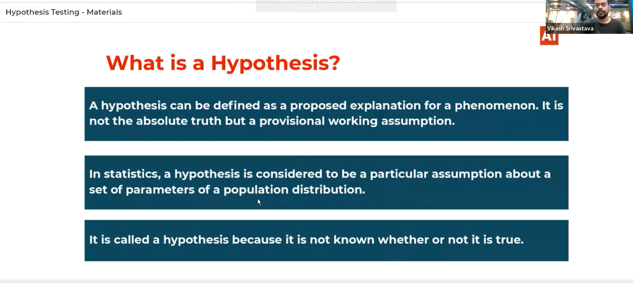

* In Hypothesis consider you want to know about the parameter of the population by considering some assumptions for example in the fuel consumption by a car after adding additives case we assumed that the fuel consumption of the car falls between the (2km,4km) per gallon. This is considered as hypothesis.
* Its defined as the assumption about the set of parameter of the population.

# Hypothesis test:

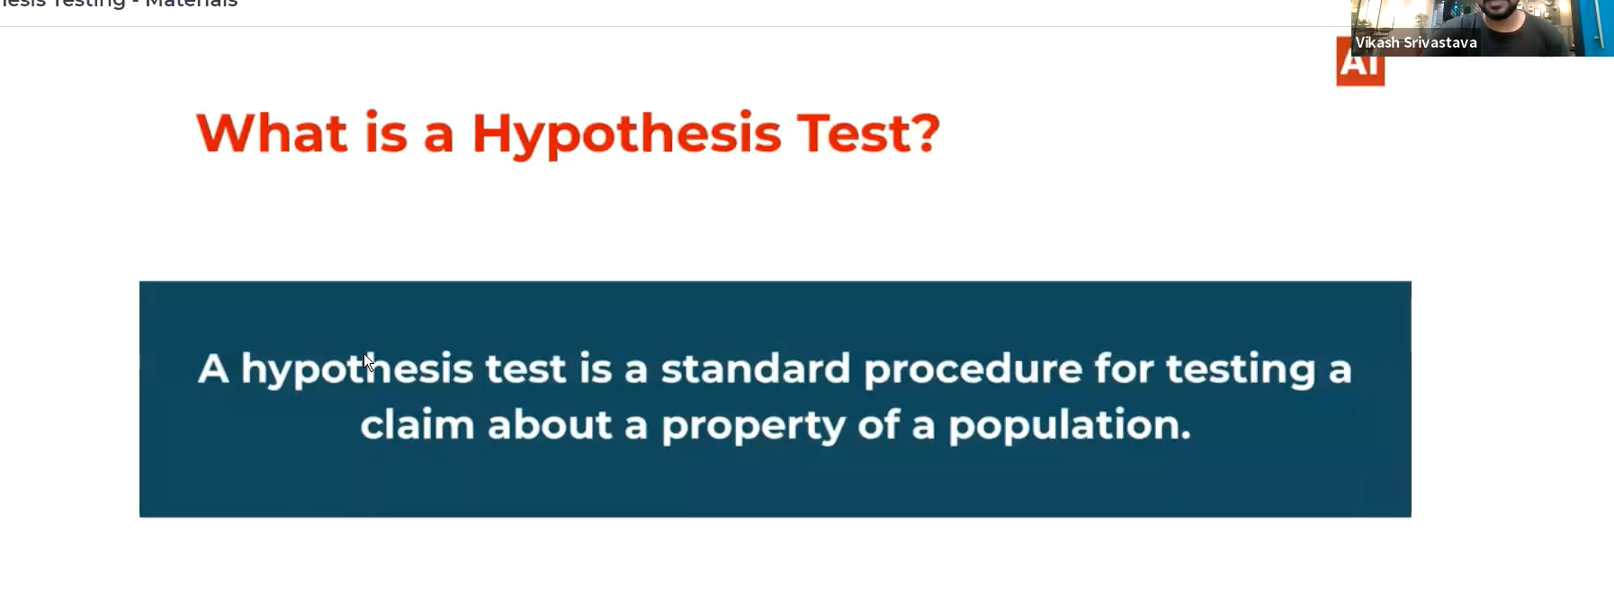

# Rare Event Rule:

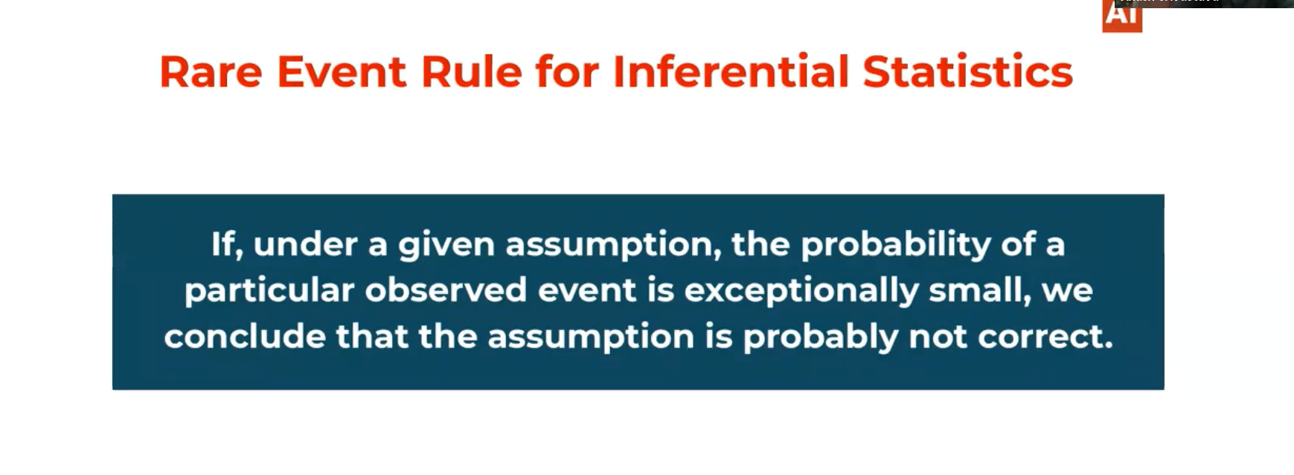

# Null Hypothesis:

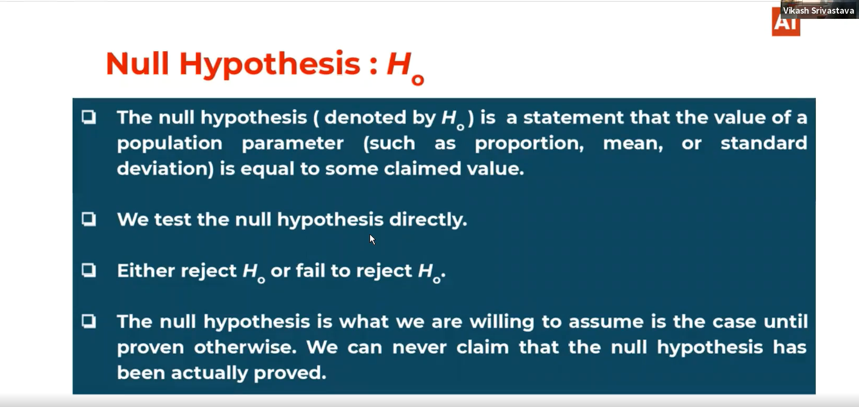

# Alternative Hypothesis:

